|  |  |
| --- | --- |
| \\VFILERDPI\DPI-Home\OBRIENR2\My Documents\Downloads\PP logo.jpg | file:///M:/Jerilderie/Public/Website/Murrumbidgee%20Council%20Intranet/web-content/Logo/MC_Primary%20Logo.jpg |
| **DEVELOPMENT ASSESSMENT REPORT**  for  **WESTERN REGIONAL PLANNING PANEL** | |

|  |  |
| --- | --- |
| DA number | DA 47/2022 |
| Type of development | Regionally significant development (as per Schedule 7, clause 5 of State Environmental Planning Policy (Planning Systems) 2021. |
| Proposed development | Electricity generating development (private infrastructure) |
| Brief description | The installation of 11,016 solar panels with a electricity generation capacity of 11,000mWh per year |
| Capital investment value | $11,794,000 |
| Property | Lots 68 & 69 DP 750877, 16705 Sturt Highway |
| Applicant | Sustainable Energy Solutions (t/a AGL Energy Solutions) |
| Land owner | Rural Funds Management |
| Relevant environmental planning instruments | Murrumbidgee Local Environmental Plan 2013  State Environmental Planning Policy (Planning Systems) 2021  State Environmental Planning Policy (Transport & Infrastructure) 2021 |
| Clause 4.6 requests | Nil |
| Submissions | Three (3). Submissions from Transport for NSW, Essential Energy and Coleambally Irrigation – no objections. |
| Documents submitted with application | Statement of Environmental effects incorporating the following appendices:   * Design plans * EBPC Protected Matters Search Tool Results * Biodiversity Assessment Report * Cultural Heritage Due Diligence, Aboriginal Cultural Heritage Assessment Report and Archaeological Technical Report * CIV Report * Visual Impact Assessment * Traffic and Transport Impact Assessment * Flood Impact Assessment * Agricultural Impact Assessment * Evidence of Stakeholder Consultation * Construction Management Plan |
| Date of lodgement | 16 December 2022 |
| Assessment officer | Mr SJ Parisotto, Senior Planner – Murrumbidgee Council |
| Recommendation | **APPROVAL** |

**PART 1: EXECUTIVE SUMMARY**

* 1. **Determining authority**

The application has been referred to the Western Joint Regional Planning Panel (‘WJRPP’) for determination on the basis that the capital investment value (‘CIV’) exceeds the threshold set out in Schedule 6, clause 5 of State Environmental Planning Policy (Planning Systems) 2021 (‘PS-SEPP’).

A briefing paper was presented to the WJRPP on 27 April 2023.

* 1. **Outline of development**

The proposed development, described as the *“Kerarbury Orchard Solar Farm and BESS”*, involves the following:

1. Installation of a photovoltaic (PV) solar array with a capacity of 4.95 Megawatts (MW);
2. Installation of battery energy storage system (BESS) with a combined capacity of up to 4.586 MWh;
3. Installation of electrical collection systems and associated structures.

The proposed development will generate up to 11000 MWh of solar power annually and will power irrigation and other operations of the Kerarbury almond orchard. Excess energy will be exported through the local grid.

A copy of the submitted documents are contained in **Schedule 1**.

* 1. **Site context**

|  |  |
| --- | --- |
| Locality | 17km south-west of Darlington Point |
| Development site | Lots 68 and 69 DP 750877 |
| Existing Land Use | Agriculture, comprising of horticultural plantings (almonds trees), including associated irrigation infrastructure and farm buildings |
| Development Footprint | 7ha |
| Setting | Irrigated farm land with their associated irrigation infrastructure, dwellings, farm buildings |
| Environment | Highly disturbed as a result of agricultural activities |

* 1. **Statutory considerations**

The proposed development accords with the provisions of the relevant environmental planning instruments and is permissible within the RU1 Primary Production zone of Murrumbidgee Local Environmental Plan 2013 (‘MLEP’) through the provisions of clause 2.36(1)(a) of State Environmental Planning Policy (Transport and Infrastructure) 2021 (‘T&I-SEPP’)

* 1. The development application was notified in accordance with the Environmental Planning and Assessment Regulation, 2021 (‘EP&A Regulation’) and Murrumbidgee Council’s Community Participation Plan (‘CPP’). One submission was received from Coleambally Irrigation Co-Operative Limited (‘CICL’), however no objections to the development were raised.
  2. The application was referred to Transport for NSW (‘TfNSW’) and Essential Energy (‘EE’). Neither in their submissions have raised issues with the development that cannot be resolved by way of conditions.
  3. The development application has been referred to the WJRPP with a recommendation for approval. A copy of the recommended conditions are set out in **Schedule 2**.

[This section has been deliberately left blank]

**PART 2: PROPOSED DEVELOPMENT**

2.1 The development involves the construction and operation of a micro solar farm with a maximum export capacity to the grid of 5 MW.

1. Installation of 11,016 ground mounted photovoltaic (PV) solar modules on single axis trackers, with a capacity of 4.95 Megawatts (MW) AC.

**Figure 1 – Solar panels and tracker**[1]

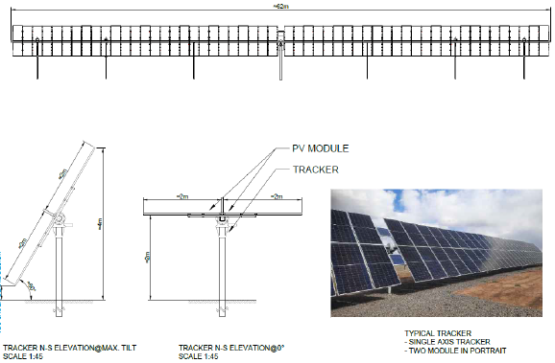

**Figure 2 – Solar panel array layout**[2]

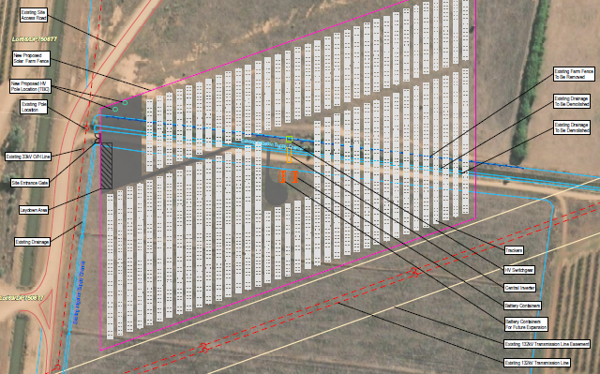

1. Installation of a two battery energy storage system (BESS) with a combined capacity of up to 4.586 MWh and associated components.

**Figure 3 – Battery container**[3]

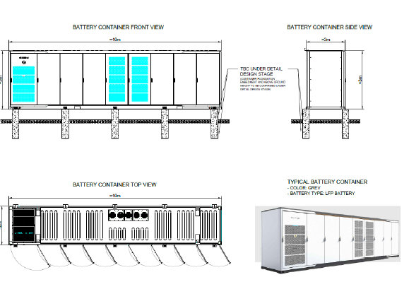

1. Electrical collection systems including switch room, control room and inverter station;

**Figure 4 – Central Inverter**[4]

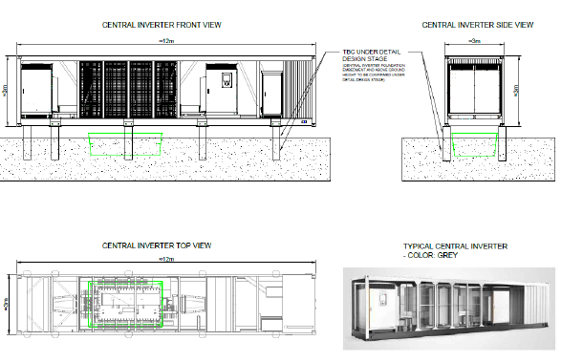

1. 1800mm chain wire fencing to secure the new plant.

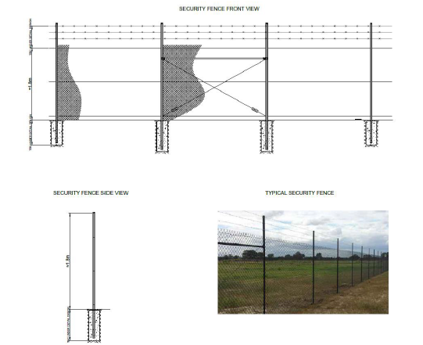**Figure 5 – Fencing**[5]

1. High voltage (HV) electrical switchgear to connect the existing privately owned HV electricity network.
2. A temporary construction hub including demountable offices, amenities, equipment laydown areas and vehicle parking facilities.

2.2 The proposed development will generate up to 11000 MWh of solar power annually and will power irrigation and other operations of the Kerarbury almond orchard. Excess energy will be exported through the local grid.

2.3 The development is for electricity generating infrastructure by a private company with a CIV of $11,794,000. It is a type of development referred to in Schedule 6, clause 5 of the PS-SEPP and declared to be regionally significant. Consequently, the development application cannot be determined by Murrumbidgee Council and the matter is required to be determined by the WJRPP.

[This section has been deliberately left blank]

**PART 3: SITE & LOCALITY**

3.1 The proposed electricity generating facility will have a footprint of approximately 7ha and will be constructed across Lots 68 and 69 DP 750877 which form part of Kerarbury Station, 16705, Sturt Highway, approximately 17 km west of Darlington Point in the Murrumbidgee local government area.[6]

**Figure 5 – Locality and site plan**[7]

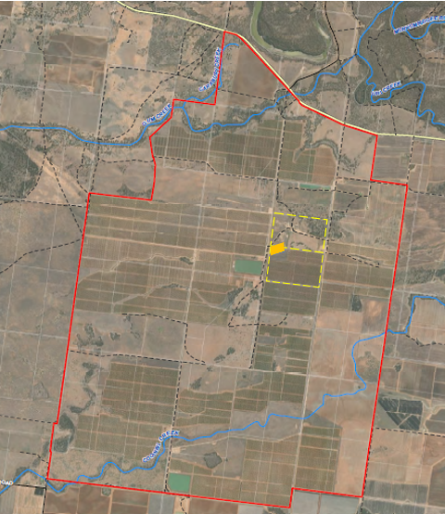

**Figure 6 – Entrance to Kerarbury**[8]

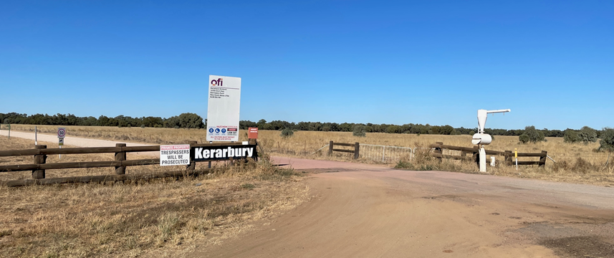

3.2 Both lots 68 and 69 in DP750877 are rectangular in shape, with an area of 105.7 and 105.2 hectares respectively. Access to the lots are via internal tracks which ultimately connect to the Sturt Highway, 3.3 kilometres to the north of the proposed site.

3.3 The terrain levels across the entire Kerarbury property is generally flat, with gentle undulations. The siting of the development is on land which can be described are very flat, varying from 118.9m to 119.0 metres AHD with an existing irrigation channel being the most notable topographic feature of the site.

3.4 The site to be developed forms part of the Kerarbury Almond Orchard. The siting of the solar farm is on land which has in the past been cleared for agricultural use, and incorporates (unused) grazing land and part of the almond plantation as shown in Figure 7 below.

**Figure 7 – Location of solar farm**

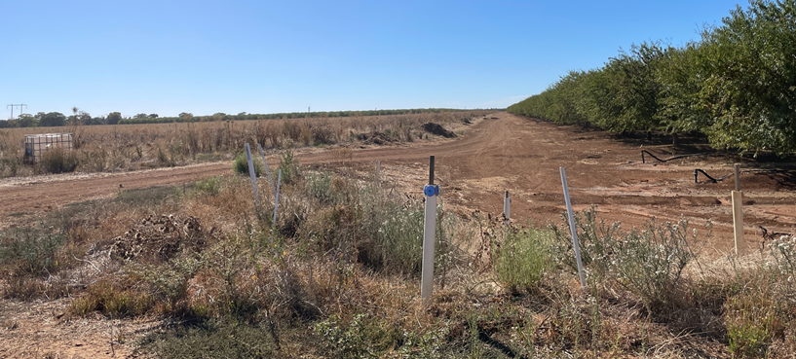

3.5 The perimeter of Kerarbury is fenced, and stock fencing within the property is also in place. Overhead power lines run north - south along the Lane and further north there is a 330kV Transgrid transmission line traversing generally east - west passes through the site.

3.6 Kerarbury Station is in a rural locality characterised by both dry land and irrigation farms, including associated infrastructure such as water supply and drainage channels and irrigation bridges over roads.

3.7 Rural dwellings, farm sheds and farm buildings are scattered about the locality with the nearest dwelling being located approximately 4.0km to the east of the development area.

[This section has been deliberately left blank]

**PART 4: STATUTORY CONSIDERATIONS**

4.1 Section 4.15(1) of the *Environmental Planning and Assessment Act 1979* (‘EP&A Act’) outlines the matters which the consent authority must take into consideration when determining a development application. These matters as are of relevance to the development application include the following:

1. *the provisions of any environmental planning instrument, proposed instrument, development control plan, planning agreement and the regulations*
2. *the likely impacts of that development, including environmental impacts on both the natural and built environments, and social and economic impacts in the locality,*
3. *the suitability of the site for the development,*
4. *any submissions made in accordance with this Act or the regulations,*
5. *the public interest.*

4.2 The proposed development does not fall within the categories of designated or integrated development and there are no concurrence authorities.

4.3 The following environmental planning instruments have been deemed relevant to this application:

* *State Environmental Planning Policy (Planning Systems) 2021*
* *State Environmental Planning Policy (Transport and Infrastructure) 2021*
* *State Environmental Planning Policy (Primary Production) 2021*
* *Riverina Murray Regional Plan 2036*
* *Murrumbidgee Local Environmental Plan 2013*

4.4 *State Environmental Planning Policy (Planning Systems) 2011* applies to the proposal as it identifies if development is regionally significant development as the proposed CIV threshold identified in Schedule 6, clause 5 of PS-SEPP has been exceeded. As a result, the application is to be referred to and determined by the WJRPP.

4.5 *State Environmental Planning Policy (Transport and Infrastructure) SEPP*

4.6 Part 2.33, Division 4 Clause 2.36 (1)(b) of the *State Environmental Planning Policy (Transport and Infrastructure)* enables development for the purpose of an electricity generating works to be carried out with development consent in a prescribed rural zone. Accordingly, the proposed solar farm (which is a photovoltaic electricity generating system) is permissible with development approval.

4.7 Part 2.3 Division 5, clause 2.48 of the T&I-SEPP requires consultation with Essential Energy as the proposal may impact electricity transmission or distribution. Given the type of the development and the proposed works, the electricity supply authority, EE, were notified and provided with an opportunity to comment on the proposal. Their comments are set out in **Schedule 3**. In summary they raised no objections to the development.

4.8 The proposed development is not located on or close to a classified road nor does it meet or exceed the thresholds identified in the Column of the Table to Schedule 3 and therefore referral to the Transport for NSW was not required under Part 2.3 Division 17 Subdivision. Notwithstanding, Council opted to refer the matter to TfNSW as access to the site is via the Sturt Highway. Their response may be found in **Schedule 3**. No objections were raised to the development.

4.9 The *State Environmental Planning Policy (Primary Production)* 2021 (‘PP-SEPP’) aims to facilitate the orderly and economic use of rural land for continued agricultural production as well as prevent land fragmentation and reduce the potential for land use conflict.

The footprint of the solar farm is approximately 7ha and this area is proposed to be enclosed with a perimeter fence. The development site will not be subdivided and the land therefore not permanently fragmented so as to potentially exclude it or increase the likelihood of it being alienated for productive agriculture into the future.

The proposal is consistent with the PP-SEPP.

4.10 The *Riverina Murray Regional Plan 2036* (‘RMRP’) provides a vision for the future of the Riverina Murray. The RMRP recognises amongst a number of matters the potential for growth of the renewable energy industry within the region with renewable energy identified as a priority growth sector. Direction 1 of the RMRP is to protect the region’s diverse and productive agricultural land.

Direction 11 of the Plan is to promote the diversification of energy supplies through renewable energy generation. The Plan recognises Transgrid’s NSW Connection Opportunities identified Darlington Point as a location with capacity for renewable energy generation. Leveraging renewable energy opportunities for the long-term sustainability of the region depends on adopting a strategic approach to new projects and incorporating small-scale cogeneration measures into the design of new developments.

4.11 The relevant local environmental plan applying to the site is the *Murrumbidgee Local Environmental Plan 2013* (MLEP).

4.12 The aims of the MLEP include:

* *The protection, enhancement and conservation of agricultural and horticultural land through the proper management, development and conservation of natural and man-made resources, and*
* *The promotion of the efficient and equitable provision of public services, infrastructure and amenities.*

The proposal is consistent with these aims as a solar farm facilitates the conservation of energy and renewable resources while ensuring that the lands continuing use for productive agriculture is not diminished.

4.13 The site is located within the RU1 Primary Production Zone pursuant to clause 2.2 of the MLEP.

**Figure 8 – Extract for MLEP 2013 Zoning Map**[9]

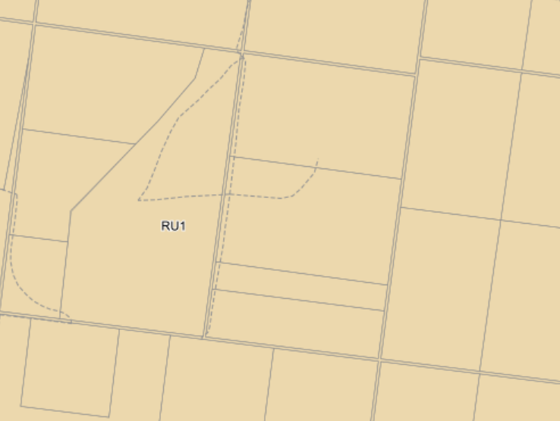

4.14 The proposed development is defined as an *electricity generating works* under the standard instrument, being.

***Electricity generating works*** *means a building or place used for the purpose of—*

1. *making or generating electricity, or*
2. *electricity storage.”*

*Electricity generating works* are a prohibited use in RU1 zone of the Land Use Table in Clause 2.3.

As identified in paragraph 4.6 the provisions of the T&I SEPP enable a consent authority to approve *electricity generating works* and the provisions of Part 2.33 of the policy.

4.15 The zone objectives include the following (pursuant to the Land Use Table in clause 2.3):

* *Encourage sustainable primary industry production by maintaining and enhancing the natural resource base.*
* *Encourage diversity in primary industry enterprises and systems appropriate for the area.*
* *Minimise the fragmentation and alienation of resource lands.*
* *Minimise land use conflict*

In considering the applicant’s Statement of Environmental Effects (‘SoEE’), Council is satisfied that the proposed development accords with the zone objectives in that:

* The project has an anticipated life span of fifteen (15) years upon which decommission of the site will be undertaken, development will be designed and operated to maintain the resource base. Upon decommissioning the site will be rehabilitated and agricultural activities would be able to continue.
* The solar farm will encourage diversity in technologies to take advantage of renewable energy and facilitate development at an expected lower economic (site specific) and environmental (broadly) costs.
* The development will not result in fragmentation of agricultural land by subdivision.
* The development has been sympathetically designed and will have measures in place to control and manage environmental impacts so that there will be minimal potential for land use conflict.

4.16 MLEP 2013 also provides directions and controls relating to development standards, miscellaneous provisions and local provisions that are considered below.

|  |  |
| --- | --- |
| *Clause* 5.10 Heritage  The objectives relate to the conservation of built and historic heritage, places of significance and aboriginal objects. | There are no items of built heritage on the development site. A due diligence assessment was carried out in accordance with the *Due Diligence Code for the Protection of Aboriginal Objects in NSW.* This identified that because the development site was disturbed agricultural land that further on site investigation was not warranted.  The development is capable of meeting the objectives of this clause provided that in the event an aboriginal object or relic is encountered, work cease and if necessary a Heritage Impact Permit be obtained if required.  In order to address the potential for unexpected discoveries a number of conditions have been recommended – refer to conditions 7 and 21 in Schedule 2. |
| *Clause 5.21 Flood planning*  The objectives relate to minimising flood risk to life and property and ensuring that the development of land was commensurate with the flood hazard, and to ensure safe evacuation and avoid cumulative impacts on flooding and the environment. | The land is not known to have been affected by flooding and is not identified as being within a Flood Planning Area. There is a low possibility of the development being affected by flooding or resulting in flood-related impacts. The development complies with this clause. |
| *Clause 6.1 Earthworks*  The objectives relate to ensuring that earthworks will not detrimentally impact on environmental functions and processes, neighbouring uses, cultural or heritage items or features of surrounding land. | Earthworks are also required to provide the construction zone, car parking area, fill for building pads, excavation for pile driven footings, the establishment of landscaping and the erection of fences. The development is capable of complying with the objectives of this clause provided that conditions are imposed for erosion and sediment control, protection of aboriginal heritage and sustainable land management taking into account soil physical and chemical properties and protection of biodiversity. Earthworks would be carried out in accordance with *AS3798-2007 Guidelines on earthworks for commercial and residential developments.* |
| *Clause 6.3 Terrestrial Biodiversity*  The objectives are to maintain terrestrial biodiversity by the protection of native fauna and flora and encouraging their conservation and their habitats and protecting ecological processes. | The map set out in Figure 10 identifies that part of the area to be developed has been mapped as being an area of biodiversity and therefore the provisions of this clause must be taken into consideration.  **Figure 9 – MLEP Terrestrial Biodiversity[10]**    It is noted that the land to be developed has not been identified on the Biodiversity Values Map (Non-EPI).  The applicant has undertaken a Biodiversity Values Assessment Report identified that the proposed development site contained primarily non-native vegetation, biodiversity would not be impacted and a Biodiversity Development Assessment Report was not required.  The report identified that the site is highly disturbed and completely cleared due to a long history of intensive agricultural and farming practices. There are no trees other than part of the almond grove within the 7ha project site, with the exception of scattered Weeping Myall.  There are no threatened ecological communities, nor were there any threatened species recorded in the project site.  The consent authority may be satisfied that the proposed development accords with the provisions of clause 6.3 of MLEP 2013 in that it will:   * not have an adverse impact on the condition, ecological value and significance of the fauna and flora on the land, and * not have any adverse impact on the importance of the vegetation on the land to the habitat and survival of native fauna, and   Further the development does not result in any potential to fragment, disturb or diminish the biodiversity structure, function and composition of the land, nor have adverse impact on the habitat elements providing connectivity on the land, and  Given the current use of the land and nature of works associated with the development it is unlikely that the development would have an impact on local native ecological communities, flora or fauna and their habitats. |
| *Clause 6.4 Groundwater vulnerability*  The objectives are to ensure the maintenance of key groundwater systems and protect groundwater resources from contamination arising from development. | The development site, as is much of the local government area has been mapped as being in a groundwater vulnerable area.  The development does not involve the use or consumption of groundwater resources and will not result in its depletion. There is the potential for degradation of groundwater to occur through leaching of chemicals that may be utilised on site and through nutrients from chemical application and from stock.  The development is capable of complying with the objectives of this clause provided that conditions are imposed regulating the storage and use of chemicals or other toxic materials and the appropriate management of stock, weeds and pasture.  Appropriate conditions have been included within the recommended conditions of consent (Condition 38 of Schedule 2). |
|  |  |
| *Clause 6.9 Essential Services*  This clause requires the consent authority to be satisfied that services essential for the development are provided-:water, electricity, storm water drainage sewage management and vehicular access | The proposed development will not require the provision of a potable water supply nor a permanent onsite waste management system. Temporary sanitary facilities, and tanked potable water will be provided during construction.  Electricity is currently provided to the site.  Access to the site is via a series of all-weather gravel (private) roads which connect to the Sturt Highway to the north.  As identified in this report TfNSW have requested that the access be upgraded.  Appropriate conditions have been included within the recommended conditions of consent – refer to conditions 8 & 9 of Schedule 2. |

4.17 The provisions of section 4.15(1)(a)(ii) require a consent authority to take into consideration any draft environmental planning instrument. In this instance there are no proposed environmental planning instruments that have been the subject of public consultation, that have relevance to this development proposal.

4.18 The provisions of section 4.15(1)(a)(iii) require a consent authority to take into consideration any draft environmental planning instrument. The only development control plan that is in force, is *Murrumbidgee Development Control Plan 1995 Village* (‘DCP’). This DCP only applies to the village areas of Darlington Point and Coleambally and consequently is not relevant, nor does it apply to this rural zoned development site.

4.19 Although not falling in the category of a development control plan, the provisions of *Murrumbidgee Council Development Contributions Plan Section 7.12 Environmental Planning and Assessment Act 1979* are an instrument that may be considered. Should the provisions of the contributions plan be applied, the required contribution is 1% of the project cost which is $117,940.00.

An appropriate condition has been included within the recommended conditions of consent (see condition 10c of Schedule 2).

4.20 No planning agreements under section 7.4 of the Environmental Planning and Assessment Act, 1979 have been entered into.

4.21 The provisions of section 4.15(1)(a)(iv) require the consent authority to take into consideration the provision of any regulation. In this instance there are no regulations of relevance to the proposed development.

## 

## 4.22 The likely impacts of development section 4.15(1)(b), including environmental impacts on both the natural and built environments and social and economic impacts in the locality have been addressed throughout the report, and in the following table.

**Table 1: Likely Impacts of proposed development**

|  |  |
| --- | --- |
| *Context and setting* | The development is compatible with its context and setting. The 7ha footprint is small in scale when compared to other larger solar farms that have been approved in the local government area. Further the solar panels and associated structures are sited away from main roads and sensitive receptors so as to be visually unobtrusive. The size of the solar arrays, their configuration and height, typically less than 4.0m would not dominate the locality in terms of mass, bulk and density.  The development is considered to have minimal impact on the rural setting in which it is proposed. |
| *Access* | Access to the development site is via the Sturt Highway to the north, and a series of internal roads.  TfNSW have requested that the access to the highway be upgraded to improve safety.  There requirements are set out in Condition 8 of Schedule 2. |
| *Traffic* | The applicant has provided a Traffic and Transport Impact Assessment (‘TIA’) prepared by The Transport Planning Partnership (‘TTPP’).  The TIA indicates that the volume of traffic during the peak construction period would result in 20 heavy vehicle movements per day, which TTPP have *“considered minimal and would not result in any noticeable impact on the surrounding road network”*.  The largest vehicle accessing the site for construction purposes would be a 19m semi-trailer whereas presently the farming operations utilise b-double configurations.  From an operation perspective, the traffic generated by the development is negligible, as monitoring is undertaken remotely. For maintenance purposes, light vehicles would access the site every six months. |
| *Air Quality* | It is anticipated that dust may be generated as a consequence of on-site construction activities as well as from vehicles using internal roads. It is considered that the applicant can implement mitigation measures to reduce the likelihood and extent of dust nuisance, including using a water cart to spray down surfaces in windy conditions and the measures mentioned above relating to road pavement.  Amenity impacts are addressed in the Construction Management Plan (CMP) and compliance with that plan is required by Condition 15 of Schedule 2. |
| *Visual amenity, glare & public domain* | The development is proposed in a sparsely populated and relatively isolated rural location, on flat ground and well setback from any public road and property boundaries. The structures are not overwhelming in their height and dimensions and the visual impact is minimal. Although the applicant is proposing to provide a landscape buffer, no condition has been imposed requiring it to be done.  The solar panels are non-reflective and the fixed tracking system of the panels will minimise the incidence and potential for glare. Given the location away from classified roads and nearby dwellings the visual impact to sensitive receptors and the public domain is considered to be acceptable.  **Figure 10 – Visual impression of solar panels[11]**    Several conditions have been recommended address amenity impacts – refer to conditions 32, 33 & 34 of Schedule 2. |
| *Noise & vibration* | The nearest residential receptor not associated with the site is located approximately 4km to the west of the development area and as such is unlikely to be impacted as a result of noise and vibration during construction nor from operational aspects of the development.  To mitigate any potential nuisance, especially from construction activities and deliveries construction is to be limited to day time hours.  Mitigation of potential noise impacts in terms of construction and operation have been addressed by conditions 19, 31 & 35. |
| *Biosecurity* | The primary biosecurity issue associated with the development is around the management of weeds in and around the development site including the road reserve. Weeds if allowed to spread have the potential to impact extensive areas of land.  It is not expected of the development to take responsibility for weed control, it is considered reasonable that the site be managed in accordance with the principles of the Australian Weeds Strategy 2017-2027 during construction, and implement measures that would mitigate the off-site migration of weeds as a result of vehicle movements.  The applicant has indicated that by implementing vehicle hygiene protocols would assist with the control of the spread of weeds.  Conditions 22 and 33 of Schedule 2 provide a broad means of addressing potential spread of weeds. |
| *Water Resources* | The contamination of surface or ground waters is unlikely to be detrimentally affected as a result of the proposed development. |
| *Land Capability Geomorphology and Soils* | The soils where the development is proposed is dominated by Vertosols (apx 7ha) and Chromosols (0.5ha)  Vertosols have a land capability class of 3, which is a more productive class able to sustain more agricultural land uses and structures must be appropriately founded with excavation, cut and fill designed to minimise soil displacement. Pile driven footings should comply with AS 2159. |
| *Biodiversity* | The impacts to flora and fauna have been considered with reference to *Clause 6.3 Terrestrial Biodiversity* in paragraph 4.16 of this report.  There are expected to be minimal impacts to biodiversity on and near the development site. |
| *Heritage* | The subject site does not contain any heritage item identified in MLEP 2013, nor have any sites or places containing Aboriginal cultural heritages been identified in the Aboriginal Heritage Information Management System (‘AHIMS’).  The applicant has undertaken a Due Diligence Assessment prepared in accordance with the Department of Environment and Climate Change (2010) *Due Diligence Code of Practice for the Protection of Aboriginal Objects in NSW* which concludes that because the site is disturbed agricultural land there is little likelihood of discovering Aboriginal artefacts.  While the potential for discovery is low, it is important that the chance finds procedure protocols be included as a condition of consent to ensure the protection of aboriginal heritage during construction. |
| *Other land Resources* | The development is not in a water catchment area nor known to contain significant minerals or other geological resources. The lifespan of the development is estimated at 15 years after which the development will be decommissioned and the land rehabilitated to its natural state so that it can continue to be used for productive agriculture. There are no known other land resources that are likely to be affected.  To ensure consistency with similar applications conditions have been included within the recommended conditions of consent (see 29 & 40 of Schedule 2). |
| *Utilities* | Essential services that are considered suitable and necessary for the development will be provided. This includes property access, power (generator), water supply (tank), and sewage disposal. |
| *Waste* | Waste generated through the construction phase will be removed from the site and either recycled, or disposed of resource recovery or waste management facility. Murrumbidgee Council has previously had issues with large volumes of waste from solar farms being deposited in local landfills with limited capacity. A Waste Management Plan (‘WMP’) will be required to be developed in conjunction with Council should disposal in the Darlington Point landfill be proposed. One of the requirements would require the separation of materials, in particular the removal of metal fasteners from timber waste to enable it to be chipped rather than placed into general waste.  The ongoing operation of the solar farm is not likely to result in waste generation and at the end of life, the development will be decommissioned and all infrastructure removed from the site and where possible recycled or reused.  Appropriate conditions have been included within the recommended conditions of consent (see 17 and 26 Schedule 2). |
| *Natural hazards* | The subject site is not prone to natural hazards such as tidal inundation, subsidence, slip, mass movement, flooding nor is it mapped as being bushfire prone land.  Despite the land not being mapped as being bushfire prone land, all land is still subject to a level of bushfire risk.  The applicant has undertaken a bushfire risk assessment in accordance with the NSW Rural Fire Service *Planning for Bush Fire Protection Guidelines (2019)*, and has prepared a Bush Fire Emergency Management and Operations Plan (BFEMOP) submitted with the development application. |
| *Technological hazards* | The development is subject to technological hazards associated with solar panels however, the risks are considered to be low.  The batteries used are lithium-ion type which are identified as a class 9 dangerous good, however are outside the scope of State Environmental Planning Policy (Resilience and Hazards) 2021 (‘R&H-SEPP’) in terms of threshold screening and pose little threat to people or property. |
| *Safety, security and crime prevention* | The development will have real-time remote monitoring allowing for constant surveillance without the need for on-site staffing. This will assist in responding quickly to emergencies.  The site and infrastructure will be secure, surrounded by a wire perimeter fence and security gate. |
| *Socio- economic* | The SoEE has identified that up to 40 people will be working at the site during the development construction phase and that several local contractors will carry out minor maintenance works over the operational life.  There is a prediction that additional employment opportunities may eventuate from the supply of goods and materials that will be required to support the construction. |
|  |  |
| *Site design* | The solar farm has been designed so that it is fit for purpose while minimising environmental impacts. |
| *Construction* | A range of potential impacts from construction have been identified throughout this assessment report and are either addressed in the applicant’s CMP or can be addressed through conditions of consent.  Several conditions have been imposed, including adhering to the submitted CMP (see conditions 15-19 of Schedule 2). |
| *Hours of Operation* | The hours of operation of the development has already been discussed above under *Noise and Vibration*. The recommended hours for construction work are 7am-6pm weekdays, 8am-1pm Saturday and no work on Sunday and public holidays. The developer has indicated that non-intrusive activities may occur outside these hours from time to time.  See condition 18 of Schedule 2, which enables the applicant to seek a variation to the approved construction hours. |
| *Buildings* | The BESS containers are not considered to be buildings because the submitted diagrams and details to demonstrate that the containers are not capable of being occupied, are prefabricated off site and is simply the housing of the inbuilt battery systems and as such the provisions of the BCA do not apply and a construction certificate is not required.  However, like other temporary structures and permanent buildings, they must be installed or founded so that they are able to resist the most critical loads and forces as per *AS1170:1,2,3 Structural Design Actions*. Plans submitted with the application show that each container is supported on pad footings.  Appropriate conditions have been included (refer to 4, 5, 6 & 14 of Schedule 2). |
| *Cumulative impacts* | Potential cumulative impacts have been considered to be insignificant. |
|  |  |

Based on the above there is unlikely to be any significant adverse impacts as a result of the development subject to the recommended imposition of conditions.

## 4.23 In terms of 4.15(1)(c) the proposed development site does not contain any significant constraints and can be appropriately serviced. Land restrictions, hazards and risks have been identified, can be reasonably controlled and managed and potential environmental impacts mitigated. The site is considered suitable and able to sustainably accommodate the solar farm development.

4.24 The provisions of the EP&A Regulation 2021 and Murrumbidgee Council’s Community Participation Plan (CPP) set down consultation, concurrence and advertising requirements for specific types of development applications and taking into consideration any submissions received in response to the notification process. In this instance, Council exhibited the development for a period of 28 days through the NSW Planning Portal, on Council’s website and adjoining landowners being informed by way of letter. Further, Council referred the application to TfNSW and EE for comment.

4.25 Three (3) submissions were received, one each from TfNSW, EE and from CICL. The submissions are set out in **Schedule 3**.

4.26 The submission from TfNSW raised no objections to the development however requested Council impose conditions of consent relating to the site’s current access to the Sturt Highway, which is a classified road. TfNSW noted that for this development application:

1. *The subject site has access to the Sturt Highway, a classified state road, in a 110 km/h zone. The Sturt Highway is an approved road train route;*
2. *The development proposes to construct and operate the Kerabury Solar Farm with a capacity of up to 4.95 MW and a battery energy storage system (BESS) with capacity of up to 4.586 MWh within the Kerabury Almond Farm/Orchard property;*
3. *Access to the site is proposed via an existing unsealed driveway to the Sturt Highway and internal roads. TfNSW believes that, at a minimum, the existing access should be upgraded to a sealed rural property access (RPA) compliant with the AGRD for a road train route i.e. sealed for a minimum width of 6 m and 10 m from the edge of seal of the Sturt Highway;*
4. *The provided Traffic and Transport Impact Assessment (TTIA) identifies that a Basic Left (BAL) turn treatment is warranted to comply with the relevant Austroads Guide to Road Design (AGRD) guidelines for the road environment. A strategic design for a sealed RPA and BAL have been reviewed by TfNSW.*
5. *A meeting was held between TfNSW, Council and the applicant’s representatives on 16 March 2023 which determined that these works would be conditioned to be completed prior to the issuing of the final certificate associated with the development.*
6. *Concurrence from TfNSW under Section 138 of the Roads Act, 1993 is required for all works within the road reserve of the Sturt Highway;*
7. *TfNSW recommends that Council consider imposing a condition of consent which requires a road dilapidation survey to be undertaken for the Monaro* [sic] *Highway in the vicinity of the development both before and after the construction of the solar farm and BESS.*

In terms of point e. TfNSW initially required that certain matters be resolved prior to the issue of the construction certificate. Following discussions between TfNSW and the applicant, and TfNSW with Council, TfNSW provided revised conditions, which are set out in condition 8 of Schedule 2.

Council in subsequent discussions with an officer of TfNSW after the briefing meeting with the WRPP sought clarification regarding the timing of road works. The advice given was that the works are necessary, and while linked to the traffic generated by the development the upgrades would also address the current agricultural use of the land. The timing of the works would be left up to Council.

Council since the briefing meeting has revisited the issue, and recommends that condition 8(l) of Schedule 2 be rewording to require all works to be completed prior to the issue of any Construction Certificate for the solar panels and BESS.

4.27 The submission from EE raised no objections to the development and, due to the proximity of existing high voltage overhead power lines (and easement) require the following matters to be complied with:

1. *The proposal (closest part – including fencing, landscaping, tree planting) must remain wholly outside the easement area.*
2. *Minimum safety clearance requirements are to be maintained at all times for any access road, as such access road passes under Essential Energy’s existing overhead powerlines located on the properties. The access road must comply with clearances for roadways, ground clearances must be maintained. Refer Essential Energy’s policy CEOM7106.25 Minimum Clearance Requirements for NSW and the latest industry guideline currently known as ISSC 20 Guideline for the Management of Activities within Electricity Easements and Close to Infrastructure.*
3. *Any access road must remain at least 1.0 metre away from any electricity infrastructure (power pole, streetlight) at all times, to prevent accidental damage.*
4. *Any excavation works in this area must comply with ISSC 20 Guideline for the Management of Activities within Electricity Easements and Close to Infrastructure.*
5. *Any landscaping, tree planting, gardens, fencing in this area must comply with ISSC 20 Guideline for the Management of Activities within Electricity Easements and Close to Infrastructure.*

In respect of the new proposed high voltage pole EE require that the applicant must follow EE’s contestable works process for installation of this pole and associated works, noting that all works will be at the applicant’s expense.

Appropriate conditions have been included within the recommended conditions of consent (refer to Condition 9 of Schedule 2).

4.28 The submission from CICL was for information purposes only and did not raise any matter that was relevant to the proposed development.

4.29 The provisions of Section 4.15(1)(e) of the EP&A Act 1979 provides an overarching requirement to consider the public interest. It is considered that the public interest is best served by the consistent application of the requirements of the relevant Commonwealth and State government legislation, environmental planning instruments, development control plan, Council policy, and by Council ensuring that any adverse effects on the surrounding area and the environmental are avoided. On the basis that the proposed development is considered to be consistent with the aims and objectives of the relevant environmental planning instruments and policies; and Land and Environment Court Planning Principles, it is therefore unlikely to raise any issues that are contrary to the public interest.

[This section has been deliberately left blank]

**PART 5: CONCLUSION AND RECOMMENDATION**

5.1 The development application has been evaluated with regard to the matters for consideration listed in Section 4.15 of the Environmental Planning and Assessment Act 1979. On the basis of this assessment it is considered the proposal has merit and the development can be supported for the following reasons:

* The proposed development is permissible within the zone under State Environmental Planning Policy (Transport and Infrastructure) and is generally consistent with the aims, objectives and provisions of Murrumbidgee Local Environmental Plan 2013.
* The proposed development is consistent with the provision the relevant SEPPs that apply.
* The proposed development is unlikely to have any unreasonable impact on the environment, and where an adverse impact has been identified appropriate conditions have been imposed to mitigate the effects.
* The subject site is suitable for the proposed development.
* The proposed development does not raise any matter contrary to the public interest.

5.2 It is **recommended** that the Development Application DA No 47-2022 (PPSWES-170) for a solar farm and battery energy storage system and associated infrastructure at Lot 68 & 69 DP 750877 16705 Sturt Highway, Darlington Point be **approved** pursuant to Section 4.16(1)(a) of the Environmental Planning and Assessment Act 1979 subject to conditions including those set out in **Schedule 2**.

1. ACLE, Project No. PRJ_50624P1 Drawing GE_6.0 Revision C
2. ERM Project No. 0640174, Statement of Environmental Effects, Figure F3-1, 30 November 2022)
3. ACLE, Project No. PRJ_50624P1 Drawing GE_3.0 Revision C
4. ACLE, Project No. PRJ_50624P1 Drawing GE_4.0 Revision C
5. ACLE, Project No. PRJ_50624P1 Drawing GE_5.0 Revision D
6. A site inspection due to be undertaken by members of the WRPP was not able to be taken on 27 April 2023 was denied by the applicant.
7. ERM Project No. 0640174, Statement of Environmental Effects, Figure F2-1, 30 November 2022)
8. © Steven Parisotto Photography, 2023 – images contained in Figures 6 and 7 taken on iPhone 12 on 16 March 2023
9. NSW Planning Portal, Murrumbidgee LEP 2013 Zoning Map downloaded 2 March 2023
10. NSW Planning Portal, Murrumbidgee LEP 2013 Terrestrial Biodiversity Map downloaded 28 March 2023
11. ACLE, Project No. PRJ_50624P1 Drawing GE_6.0 Revision D